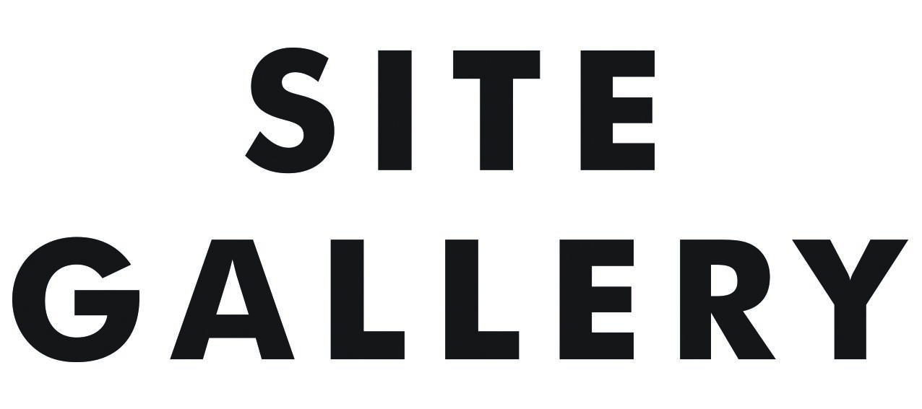

**Application Pack: Programme Producer**

Dear candidate

Thank you for your interest in working with us at Site Gallery. If you have a passion for contemporary art, with at least 2 years relevant professional experience and a positive attitude to making things happen, then we’d love to hear from you.

We work with emerging and established artists from across the UK and internationally to deliver an annual programme of exhibitions, artist development, participation and dedicated community programmes. We work with artists from a range of backgrounds and lived experiences, and are committed to platforming voices who are underrepresented in contemporary visual arts.

This role offers a fantastic opportunity for someone to work on all aspects of our exhibitions and artist development programmes, helping to shape our work and contribute to the success of the organisation. You will work closely with our Head of Programme and sit within our programme team, contributing to all aspects of our creative activity.

Working at Site Gallery is a rewarding experience. We are a small team of 13, very collaborative and pro-actively encourage everyone to develop their professional skills and experience. We take care of our staff and are committed to enabling a positive work/life balance. We offer benefits of a 4-day week, flexible hours and hybrid working, all carefully managed to ensure we prioritise the needs of our audiences and communities we serve.

We care deeply that the work we create is relevant to our city and to people living in Sheffield. It is critical that our team is representative of the wide range of communities we engage with. Fair access to working in the arts and cultural sector is an urgent issue and we are always keen to hear from candidates from lower socio-economic backgrounds and with protected characteristics still significantly under-represented amongst the artists and employees of UK arts organisations. Site Gallery can support an Access to Work application, offers flexible working arrangements and we are open to discussion about additional support/resources that might be required.

Applications are now open. The closing date is 10am Monday 24 February 2025. Please see below for details of how to apply.

For an informal conversation about the role or any additional support please contact us by emailing jobs@sitegallery.org to request a phonecall.

I look forward to hearing from you,

Judith Harry, Chief Executive

**Application Pack**

**About Site Gallery**

Site Gallery is Sheffield’s leading international contemporary art space, supporting artists specialising in moving image, sound and performance. Pioneering emerging and diverse art practices and ideas, we work with local, regional and international collaborators to nurture artistic talent and support the development of contemporary art. We connect people to artists and to art, inspiring new thinking and debate through our exhibitions, projects, public programmes and participatory activity. We pride ourselves on our openness, collaborative spirit and passion for advancing the role of art in society.

**Key Goals 2025-2030**

1. Create an ambitious, diverse, research-led programme which connects audiences to exceptional artists, critical debates and conversations.

2. Build long-term relationships with communities in Sheffield to co-produce meaningful programmes that empower participants and affect positive local change.

3. Nurture talent, creating pathways for progression and professional development for artists, participants, volunteers, freelancers and staff.

4. Embrace change, working to create an inclusive, accessible, equitable and environmentally responsible organisation.

5. Foster strategic partnerships across arts, community and policy to advocate for change; making Sheffield a more inclusive, sustainable and creative city to live, work and visit.

Celebrating our 40th anniversary in 2018, Site Gallery re-opened after a programme of expansion and refurbishment. Trebling the size of our public offer, we have a 290sqm gallery and a dedicated events space along with commercial spaces including a shop, café and business-let units. We are a creative hub and catalyst for the arts and creative industries in Sheffield; and a platform for international contemporary arts in a dynamic, exciting and transforming city.

**About this role**  
  
The Programme Producer is a key facilitator role within the organisation and ensures all programmes of work relating to exhibitions, commissions, artist development and public programme run smoothly. The majority of the Programme Producer’s time will be spent working with colleagues, artists and partners on the logistics of delivering artistic programmes.

The role sits within the Programme Team at Site Gallery and is line managed by Laura Clarke, Site’s Head of Programme. The postholder will be able to draw on expertise and experience from our artistic staff, and will receive training on internal systems and procedures from colleagues. They will be expected to commit to training, self learning and professional development.

This is a permanent position at Site Gallery, which has become vacant due to our current Producer resigning. It is offered on a 0.8 basis which equates to 25.6 hours per week and the salary level will be adjusted pro rata.

**Job Description**

Employer: Site Gallery Ltd, 1 Brown Street, Sheffield, S1 2BS

Position: Programme Producer

Salary: £24,000 - 29,000 depending on experience, pro rata

Contract: This is permanent contract offered on a 0.8 basis (hour)

Responsible to: Head of Programme

**Key Responsibilities**

1. Lead the production of new commissions, exhibitions and artist development activity, ensuring all is delivered to high standards, on time and to budget.
2. Contribute ideas to the development of Site’s artistic programme, devise and deliver public events, digital content and support audience engagement.
3. Support the Programme team with administration, reporting and fundraising activity.

**Key Tasks**

1. Contribute to programme planning and the development of themed activity, providing research and proposing ideas, potential artists, partners and communities with whom we may engage.
2. Support all aspects of the development of new commissions and exhibitions; providing robust administrative and logistical support, being the first point of call for artists including access support, carrying out research, devising plans for project development and delivery, sourcing and purchasing materials, organising transport, travel and accommodation, supporting projects through from concept to delivery.
3. Lead the delivery of Site’s artist development programmes, ensuring best practice in working with artists and creating opportunities for artists’ professional and artistic development.
4. Work with Site’s Technical Producer and Head of Programme to plan and deliver the installation of exhibitions to the highest possible standards ensuring communication between all parties.
5. In collaboration with the Programme team, devise events designed to deepen visitor experience and reach new audiences. Ensure the smooth delivery of events, including talks, workshops, live performances, providing excellent audience experience.
6. Draft text, source images, provide logos and other details for Marketing Communications, ensuring deadlines are adhered to and texts are signed off by relevant parties.
7. Gather data and capture learning to contribute to the process of evaluating our work, both to provide analysis to funders and stakeholders and to aid internal planning and development.
8. Contribute to the identification of potential collaborators and funding sources in order to increase resources for planned activity.
9. Ensure robust administration processes and delivery are in place, updating budgets, schedules, communications, data collection, using systems that are already in place.
10. Support internal systems and operations at Site Gallery through attending meetings, working as a team member, sharing knowledge with staff members and volunteers.
11. Providing occasional Duty Management cover, as required and rota’d.
12. Act in accordance with Site’s Code of Conduct, Equality Policy and Health and Safety guidelines and other policy frameworks.

1. Commit to own professional development through self-initiated research, learning through professional practice and seeking training courses where necessary and/or budget allows.
2. Any other duties commensurate with the role.

**Skills, Knowledge and Behaviour**

You will have a good track record of at least two years working within a cultural organisation to deliver public exhibitions and events. Experience is more important than qualifications and we do not have a minimum level of education attached to this role.

You are sensitive to the needs of artists, their creative processes and types of support they might require to develop new work. You are highly organised and effective in planning and prioritising your work around the needs of both artists and the organisation. You are an effective problem solver, able to think on your feet, consult effectively and make quick judgements when needed. You have a positive attitude, can take the initiative and take responsibility for resolving problems. You have a good understanding of team work, able to communicate well with different stakeholders. And you will need to be responsive, flexible and caring in this role, and able to develop ideas and solutions collaboratively.

You will have an active interest in contemporary visual art and be willing to contribute ideas to the development of Site Gallery’s artistic programme.

**Recruitment:**

This role is advertised from from Friday 17th January 2025.

**How to apply:**

We want to make the application process as accessible as possible. You can choose to submit your information in any of the three options below. If you want to apply in a different way, please get in touch via [jobs@sitegallery.org](mailto:jobs@sitegallery.org) and we’ll arrange to talk to you about your application.

**Option 1:**

Please submit a C.V. of no more than 2 sides of A4, with a covering letter of no more than 1 side of A4, outlining your interest in the job and what you will bring to the role.

**Option 2:**

Please submit a C.V. of no more than 2 sides of A4, and an audio recording or short film outlining your interest in the job and what you will bring to the role.

The recording should be no more than 3 minutes

**Option 3:**

You can submit your entire application through an audio or film recording. Please talk about your CV for no more than 3 minutes and discuss your interest in the job and what you will bring to the role in no more than 3 minutes.

Applications should be submitted via email to [jobs@sitegallery.org](mailto:jobs@sitegallery.org). You will receive an automated email confirming receipt of your application.

**Deadline for applications: 10am, Monday 24 February 2025**

**Interviews are scheduled for: Thursday 13 March 2025**

We ask all applicants to complete an Equal Opportunities form to help us monitor the reach of our job adverts. [Please follow this link to complete the form.](https://docs.google.com/forms/d/e/1FAIpQLScKY-TaBKnxdngEEYqzLS2Jpz8CTf-H-brTev8AAd19ysM-FA/viewform)

We are an equal opportunities employer and encourage applications from a diversity of backgrounds.